Test name: verifyLoginWithValidUserNameAndPasswordTest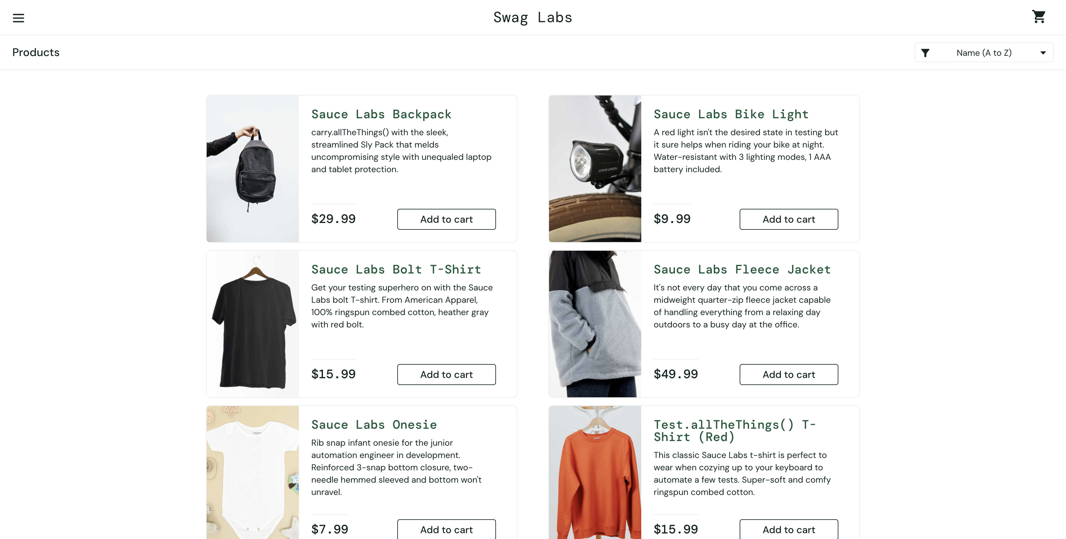

Test name: verifyLoginWithValidUserNameAndPasswordTest

Test name: filterHighToLowTest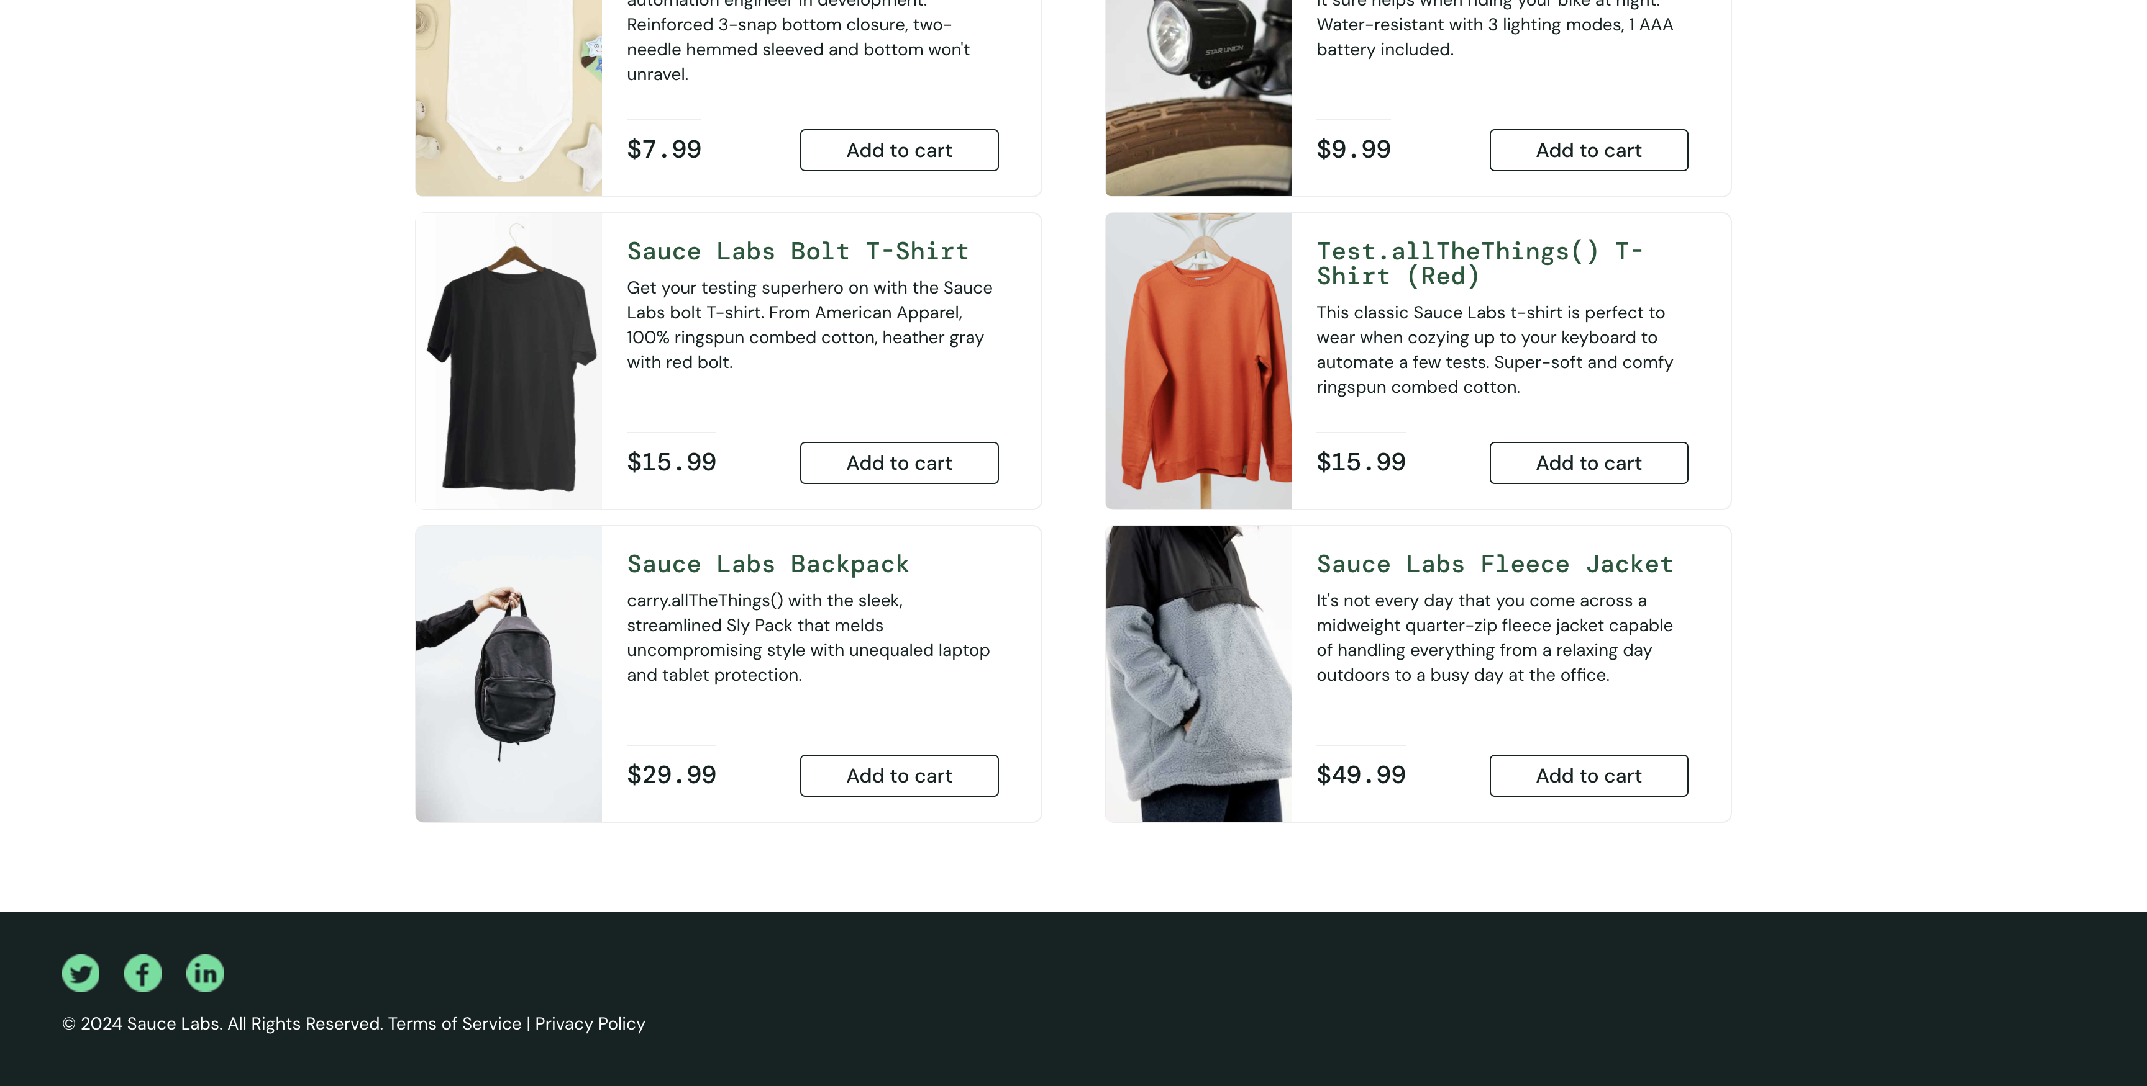

Test name: verifyLoginWithValidUserNameAndPasswordTest

Test name: verifyLoginWithValidUserNameAndPasswordTest

Test name: filterAtoZTest

Test name: filterZtoATest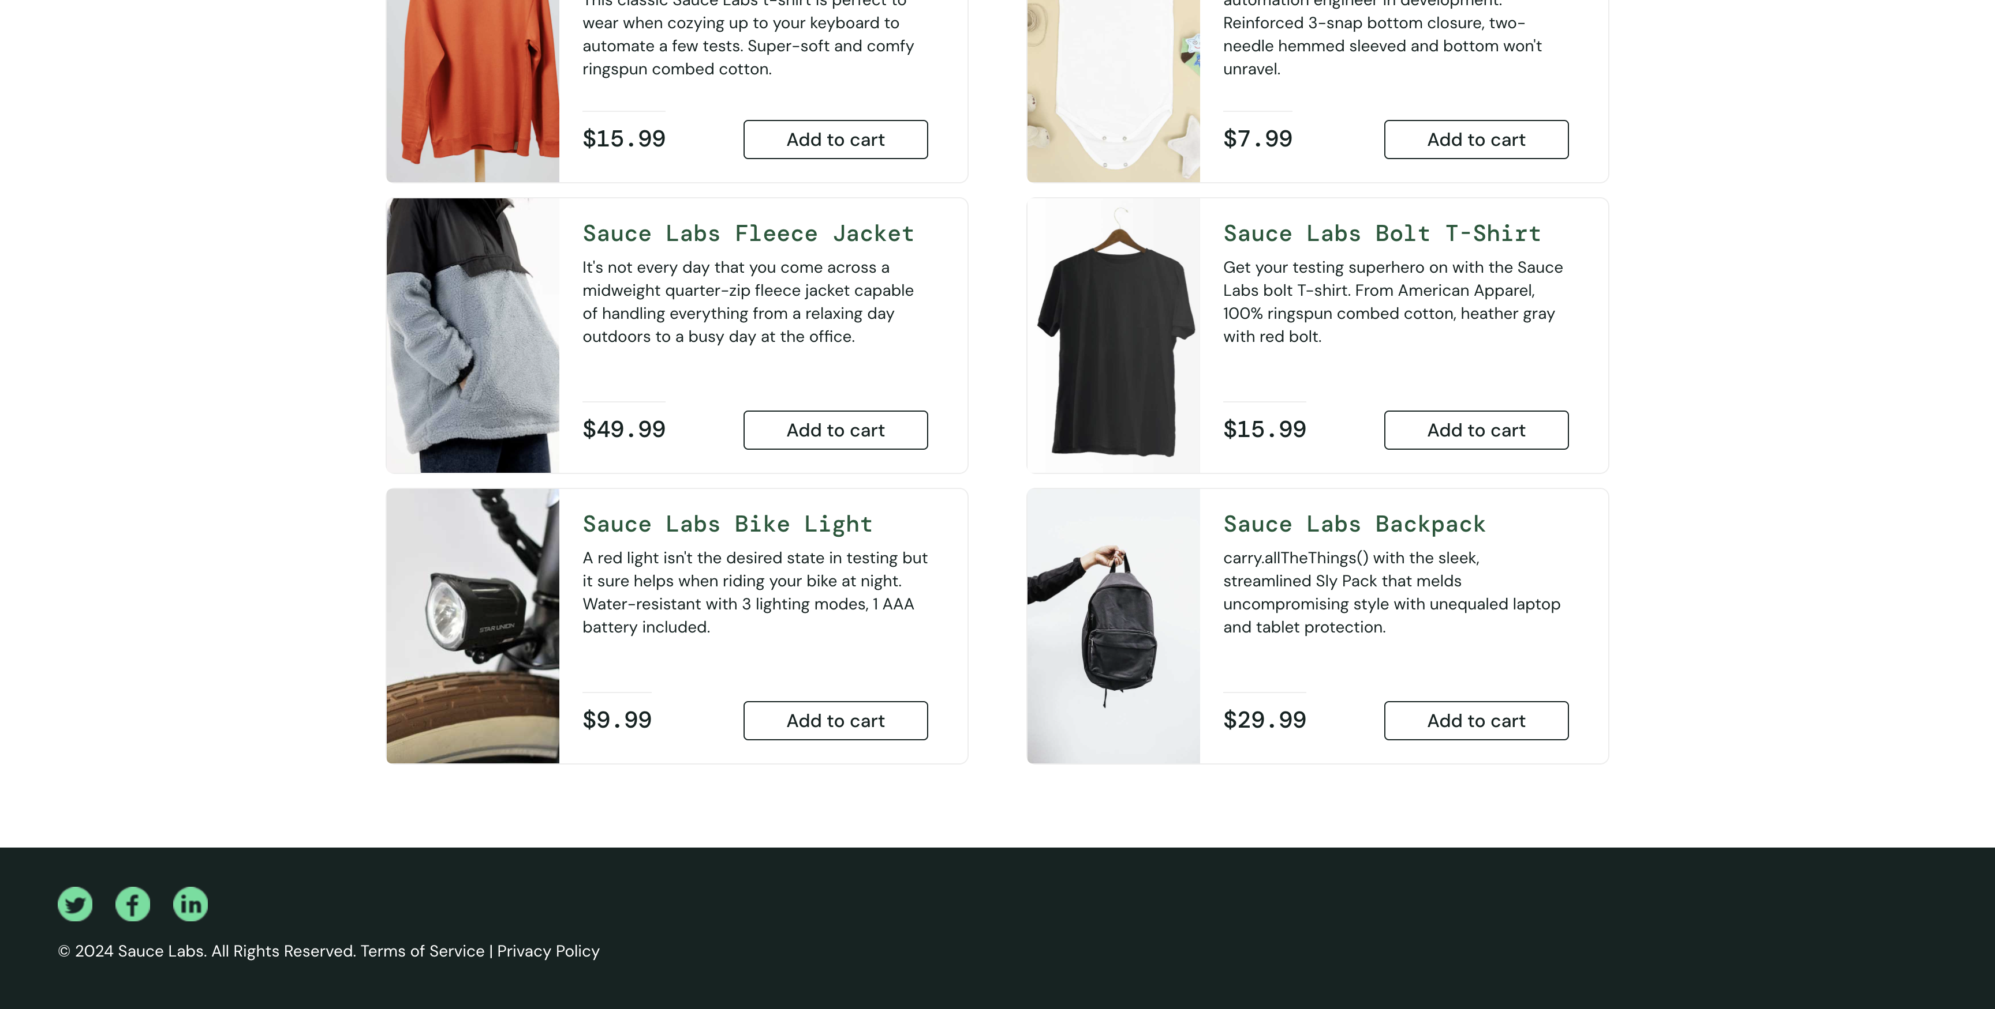

Test name: filterZtoATest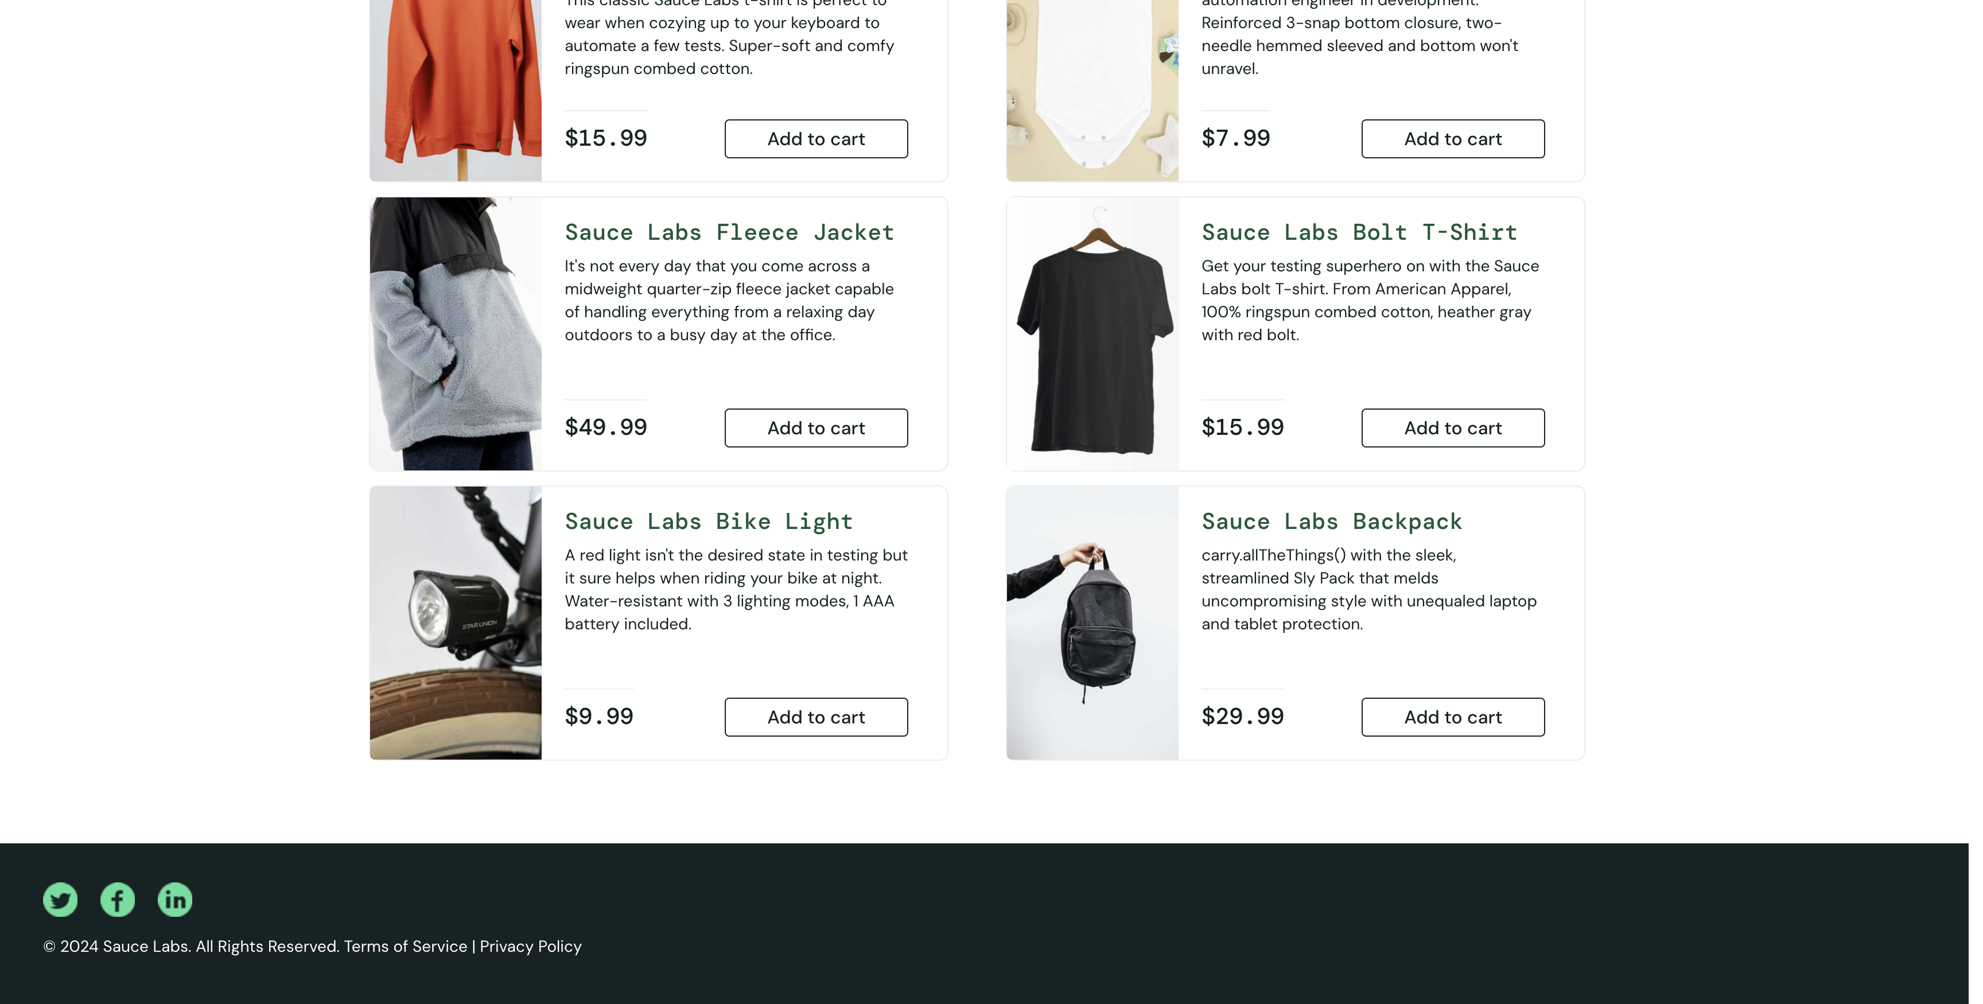

Test name: filterLowToHighTest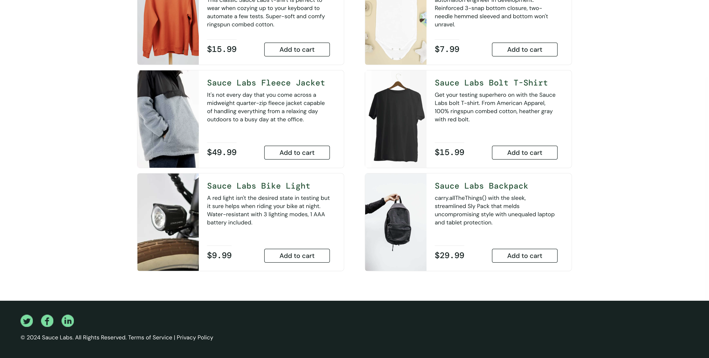

Test name: filterHighToLowTest

Test name: filterZtoATest

Test name: filterZtoATest

Test name: filterHighToLowTest

Test name: filterHighToLowTest

Test name: filterHighToLowTest

Test name: filterHighToLowTest

Test name: filterHighToLowTest

Test name: verifyLoginWithValidUserNameAndPasswordTest

Test name: verifyLoginWithValidUserNameAndPasswordTest

Test name: verifyLoginWithValidUserNameAndPasswordTest

Test name: verifyLoginWithValidUserNameAndPasswordTest